Virtual Campus Tour

COMP 1536 Website Development Project

Simon Wu

Ian Lo

Jacky Li

Akemi Haraguchi

Table of Contents

[Milestone 4: 5](#_Toc477963266)

[Changes from Milestone 3: 5](#_Toc477963267)

[Javascript or Jquery third party widget: 5](#_Toc477963268)

[Testing form without Javascript: 5](#_Toc477963269)

[Publish site and test: 6](#_Toc477963270)

[Milestone 3: 6](#_Toc477963271)

[URL where all work completed so far can be viewed 6](#_Toc477963272)

[List of items completed for this milestone 6](#_Toc477963273)

[Any additional work on top of what is required for this milestone, if any 7](#_Toc477963274)

[Key issues, including those outstanding, which was encountered in building the site 7](#_Toc477963275)

[Any deviations from the proposal (Milestone 1) and design (Milestone 2) and why 7](#_Toc477963276)

[A/B Testing Progress 8](#_Toc477963277)

[MILESTONE 2 11](#_Toc477963278)

[PROJECT SITE MAP 11](#_Toc477963279)

[COLOR SCHEME 12](#_Toc477963280)

[PAGE LAYOUT 13](#_Toc477963281)

[HOME 13](#_Toc477963282)

[HOME (PRINT PAGE) 13](#_Toc477963283)

[BUILDINGS INFO 14](#_Toc477963284)

[BUILDINGS INFO (PRINT PAGE) 14](#_Toc477963285)

[BUILDINGS 15](#_Toc477963286)

[BUILDINGS (PRINT\_PAGE) 15](#_Toc477963287)

[CONTACT 16](#_Toc477963288)

[CONTACT (PRINT PAGE) 16](#_Toc477963289)

[GLOSSARY 17](#_Toc477963290)

[GLOSSARY (PRINT PAGE) 17](#_Toc477963291)

[USER LOGIN 18](#_Toc477963292)

[USER LOG-IN (PRINT PAGE) 18](#_Toc477963293)

[USER ADMINISTRATION 19](#_Toc477963294)

[USER ADMINISTRATION (PRINT PAGE) 19](#_Toc477963295)

[USER REGISTRATION 20](#_Toc477963296)

[USER REGISTRATION (PRINT PAGE) 20](#_Toc477963297)

[APPENDIX 1: MILESTONE 1 21](#_Toc477963298)

[PROJECT SUMMARY 21](#_Toc477963299)

[MISSION 21](#_Toc477963300)

[GOAL/OBJECTIVE 21](#_Toc477963301)

[COMPARASION WITH SIMILAR SITES 21](#_Toc477963302)

[PROJECT SUMMARY 22](#_Toc477963303)

[MEASURING SUCCESS 22](#_Toc477963304)

[FUNCTIONAL REQUIREMENTS 24](#_Toc477963305)

[THE LOG-IN FEATURE 24](#_Toc477963306)

[USER AUTHENTICATION 24](#_Toc477963307)

[SERVER SIDE PROCESSING 24](#_Toc477963308)

[OTHER FEATURES 24](#_Toc477963309)

[PROJECT EXECUTION PLAN 25](#_Toc477963310)

[SCHEDULE 25](#_Toc477963311)

[PLAN 25](#_Toc477963312)

[ROLES 26](#_Toc477963313)

[DEADLINES 26](#_Toc477963314)

[ADDENDUM 26](#_Toc477963315)

# Milestone 4:

## Changes from Milestone 3:

We were finally able to implement the theme that was voted on during A/B testing. We had to make it from scratch again to ensure that everything worked, with extra care taken so that we didn’t run into the same mistake. To improve appearances we also made a drop down nav bar using CSS/html, and made it transparent so that the banner is still visible a little bit. There’ll probably be more changes to the theme in the future, but hopefully nothing as large-scale as this --- Will keep on updating as we go!

## Javascript or Jquery third party widget:

We weren’t quite sure exactly what kind of third party app we wanted for our website, because we don’t have all the content yet. While it was hard to predict what we’ll need in the future for now we’ve added a weather widget on the banner and a map widget on the Contact Us page. We’re thinking of other widgets to add in the future, but for now these will do.

## Testing form without Javascript:

The form works fine without javascript enabled, and submitting works as well. Of course, none of the validation works unfortunately. Because we don’t have server-side processing yet, while the log-in page works, we can’t actually log in. If a required field is not filled in, it warns us as well.

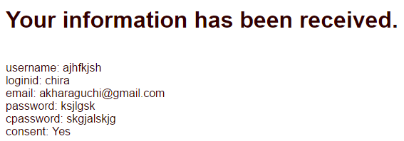

Figure 1- after submtting the registration form with JS disabled.

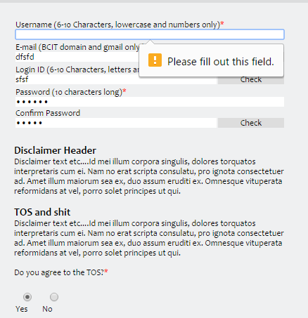

Figure 2- Attempting to submit the form without filling in a username.

## Publish site and test:

Publishing the site came with no problems. Other than the problems listed below in their individual tables, minor problems such as adding the server that forms go to, external javascript files, and amalgamation of CSS styles/ already established websites were observed. Most of these problems were addressed well before the deadline, and we generally felt more prepared than the last milestone.

# Milestone 3:

## URL where all work completed so far can be viewed

* Layout A: <http://students.bcitdev.com/A00773676/Project/BTest/glossaryB.html>
* Layout B: <http://students.bcitdev.com/A00773676/Project/Master_Simon/Home.html>

## List of items completed for this milestone

* All required skeleton sites (Home, Login, Registration, Building routing page, Specific building info, Glossary – base.css along with header/footer should be uniform throughout all, with difference only in the content, which then a page-specific .css would be loaded after base.css)
* Site map is added to the footer instead of having another page (ease of access)

## Any additional work on top of what is required for this milestone, if any

* Mopping up of additional layouts, as some uncompleted layouts were voted higher
* Names for classes and ids for divs NEEDS to be named according to their general position in the web page instead of style
* Debugging height issues in base.css

## Key issues, including those outstanding, which was encountered in building the site

* Master.css and Master.html should be styled, organized, and understood by everyone.
* Master.css should have SPECIFIC elements/id/classes that should not be overwritten by page specific .css
* Wrapper divs are important, especially the ones that wrap specific divs that should be styled together (e.g. 1 line of css instead of 2)
* More A/B testing needed, as unexpected errors interfered in deciding on layouts, and on layouts that “functioned”
* Responsiveness of the web page should be fully tested in all sizes

## Any deviations from the proposal (Milestone 1) and design (Milestone 2) and why

* Basic layouts of the skeleton pages were changed from Milestone 2 to make the page more accessible and less cluttered (minimalistic view is best to not make clutter)

|  |  |
| --- | --- |
| Nav bar was moved to be horizontal instead for layout A, for Layout B the Nav bar was made invisible until moused-over. This was done to maximize the view for the actual content (horizontal nav bar and invisible) and to setup the site for perhaps mobile viewing (horizontal nav). Also, it looks nicer.  Figure - Login skeleton to be implemented into the base.html and base.css | Figure - Registration skeleton to be implemented into base.html and base.css |
| Figure - Layout A | Figure - Layout B |
| |  | | --- | |  |  A/B Testing Progress  * We started with designing the navigation bar, while getting feedback from our classmates during class. * Early on it was decided that a vertical bar was less intuitive, especially with the kind of drop down features we had in mind. (There were a lot more buildings than we thought.) * We started working on a horizontal nav bar instead, resulting in a prototype that worked. * After some thought, it was decided that we should make an A version with the vertical bar and B version with a horizontal bar. * During this process we continued to get our classmates’ feedback during breaks and labs. * After designs were finalized, we uploaded them and sent it for the final voting, which was distributed on social media sites and friends of the group members. * We ran into challenges where we had designed the contents at the same time as the general layout, making amalgamation quite difficult as everybody has unique coding styles.   Figure - Our second attempt at design.  **https://cdn.discordapp.com/attachments/270996599864426497/282041545945776130/unknown.png**  Figure - Our very first attempt at website design  Figure 9- Final A/B testing results  Figure - Some comments by those online who voted. | |

|  |
| --- |
|  |

# MILESTONE 2

## PROJECT SITE MAP

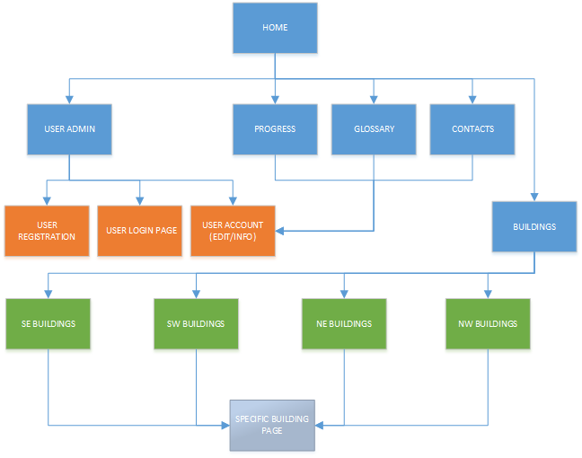

Figure 1 - Project Site Map

## COLOR SCHEME

The color scheme for this website will be similar to BCIT’s site just to be consistent.

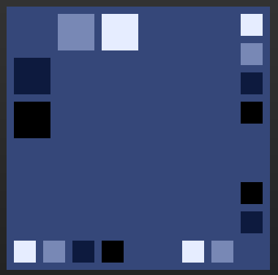

Figure 2 - Color Palette for Site

[Click here for the color palette link.](http://paletton.com/" \l "uid=13N0u0kk8my3y++c8zssob-F900)

If not all of these colors have enough contrast between them, countermeasures such as an 80% opacity white background behind the text will be utilized where needed.

|  |  |
| --- | --- |
| C:\Users\Jacky\AppData\Local\Microsoft\Windows\INetCache\Content.Word\Website_Layout_Coloured.png  Figure 3 - Sample Color Scheme for FrontPage | As seen on the left, not all colors from the palette will be utilized, further elucidation in future versions will be available.  Contrasting colors will also be used for outstanding content, if need be. |

## PAGE LAYOUT

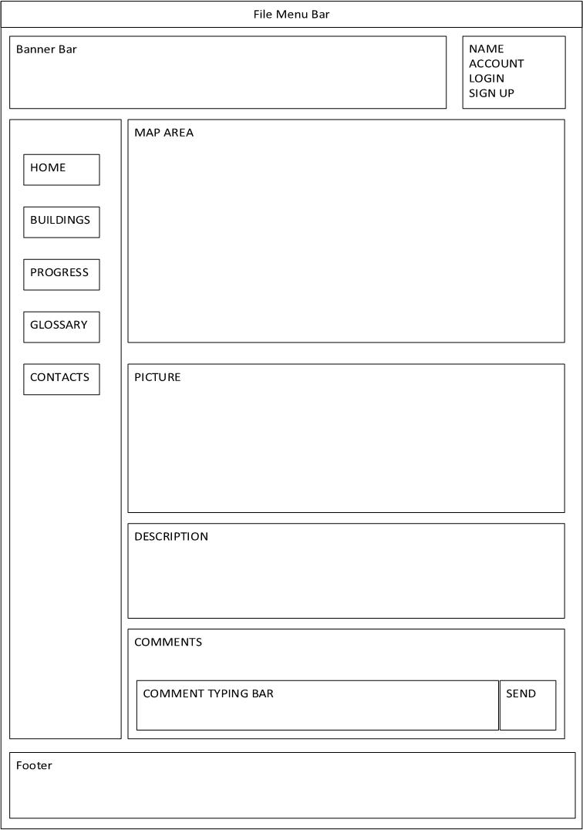**HOME**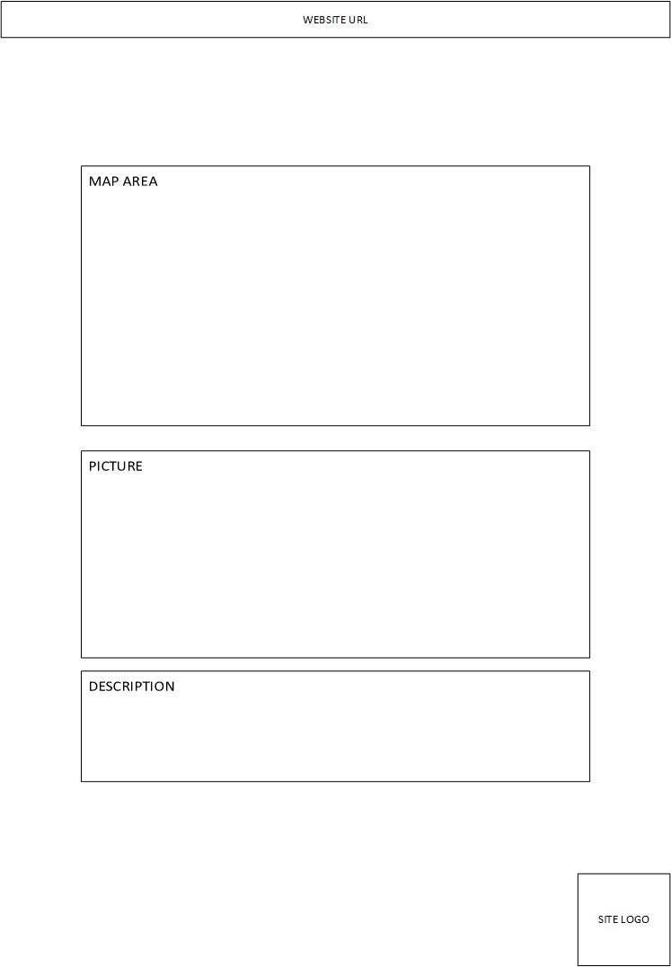HOME (PRINT PAGE)

Figure 4 - The homepage will show the interactive BCIT map.

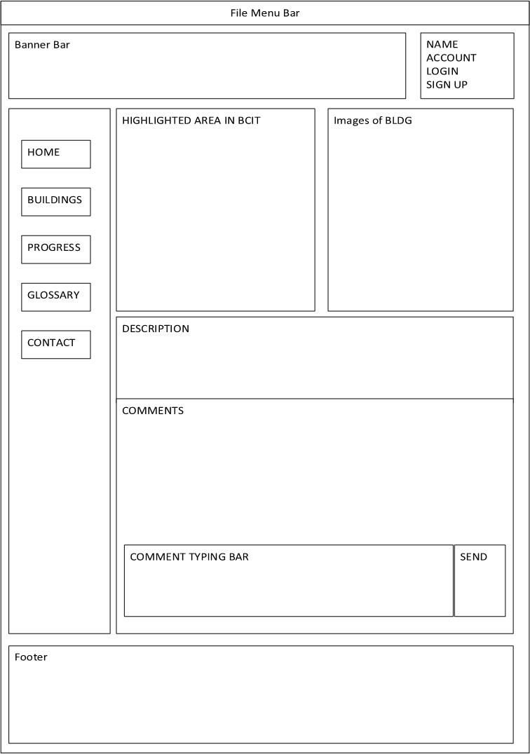**BUILDINGS INFO**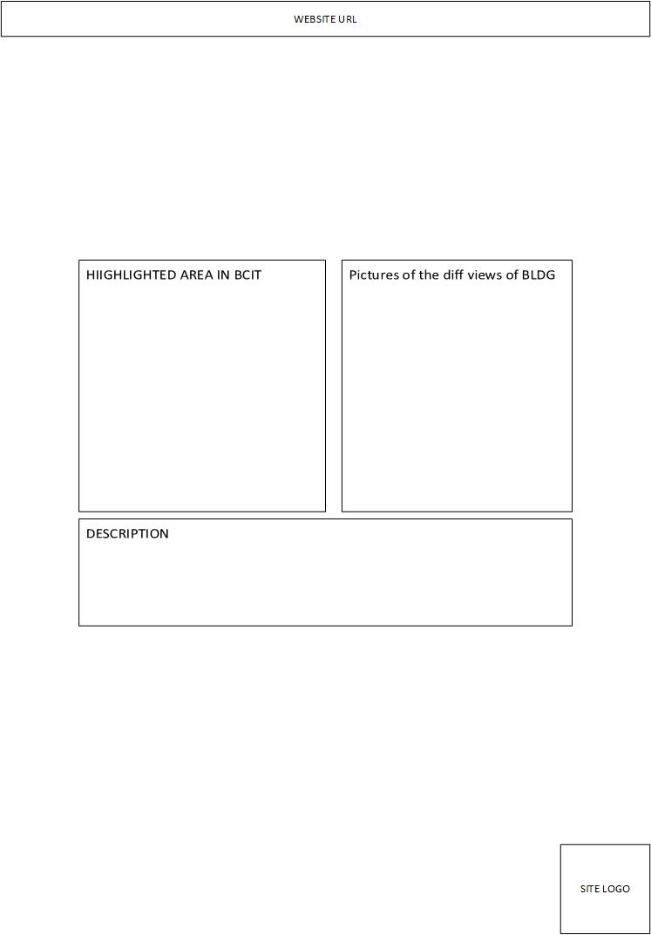BUILDINGS INFO (PRINT PAGE)

Figure 5- This page is available once the user selects the desired building.

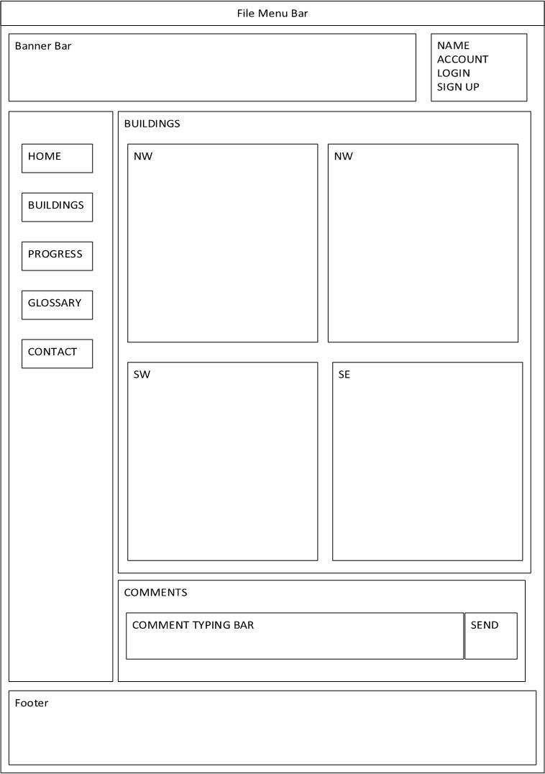**BUILDINGS**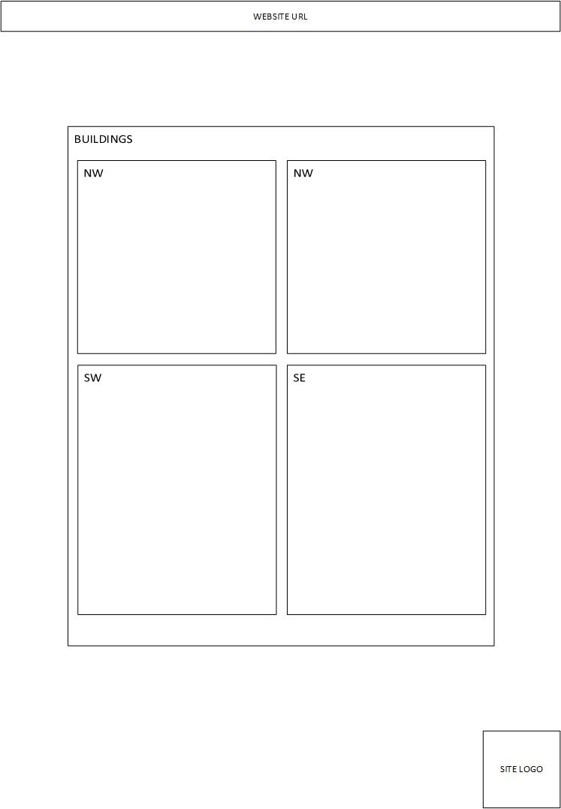BUILDINGS (PRINT\_PAGE)

Figure 6 - This is an option for users who may want to search by building rather than where they are.

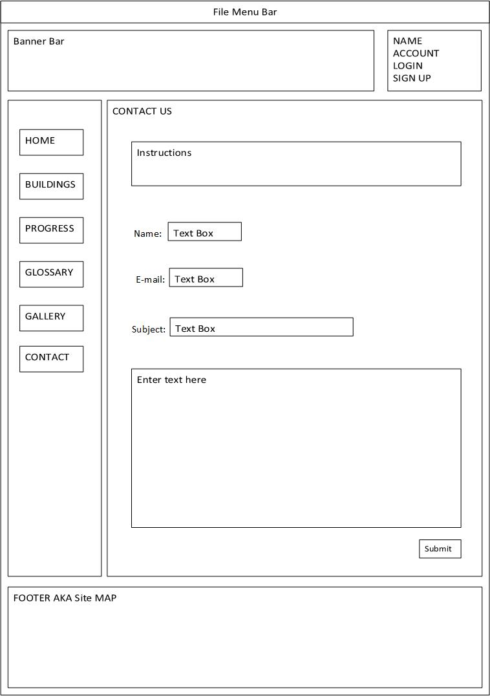**CONTACT**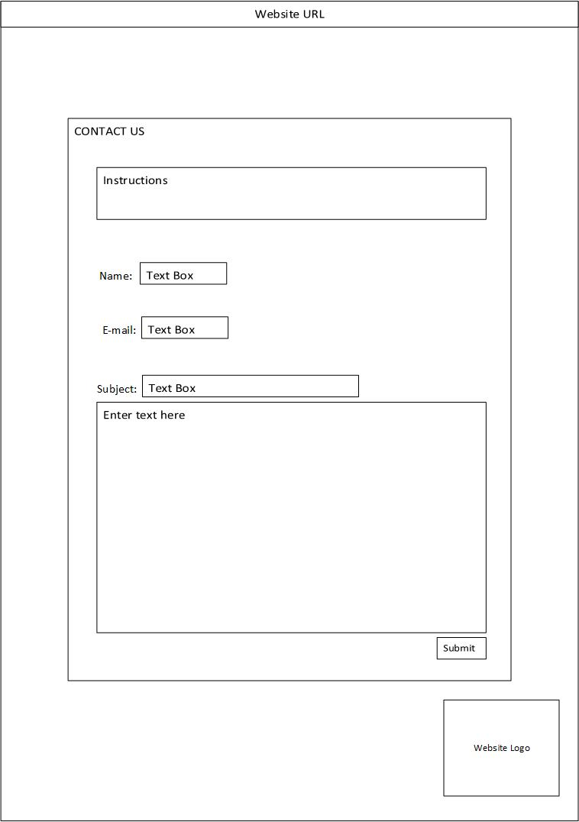CONTACT (PRINT PAGE)

Figure 7 - Users may contact the developers directly from this page.

### **GLOSSARY**GLOSSARY (PRINT PAGE)

Figure 8 - Glossary, equipped with a comments section so suggestions can be given out by users.

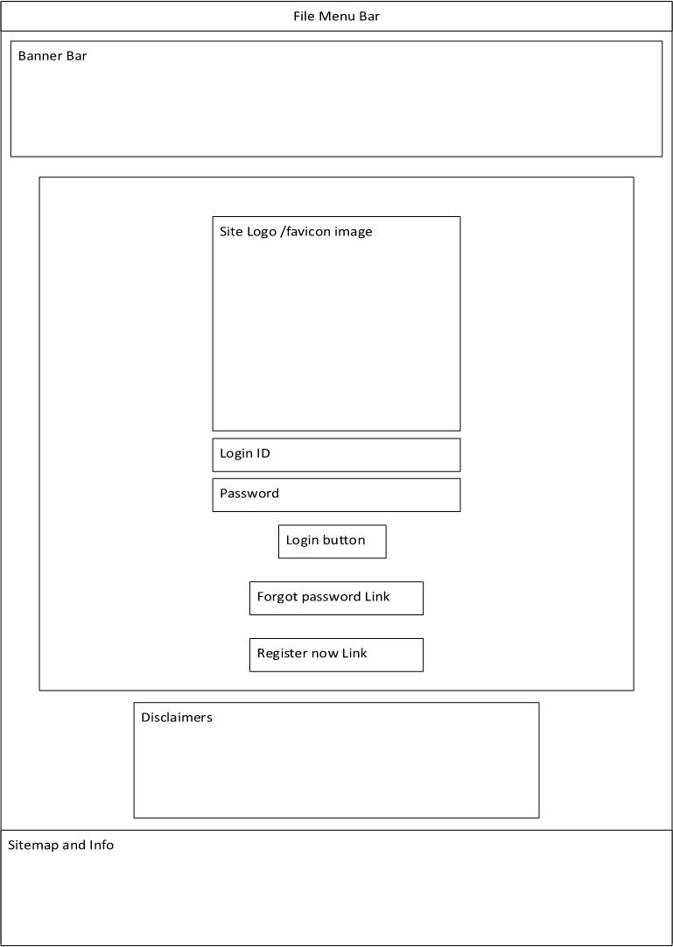**USER LOGIN**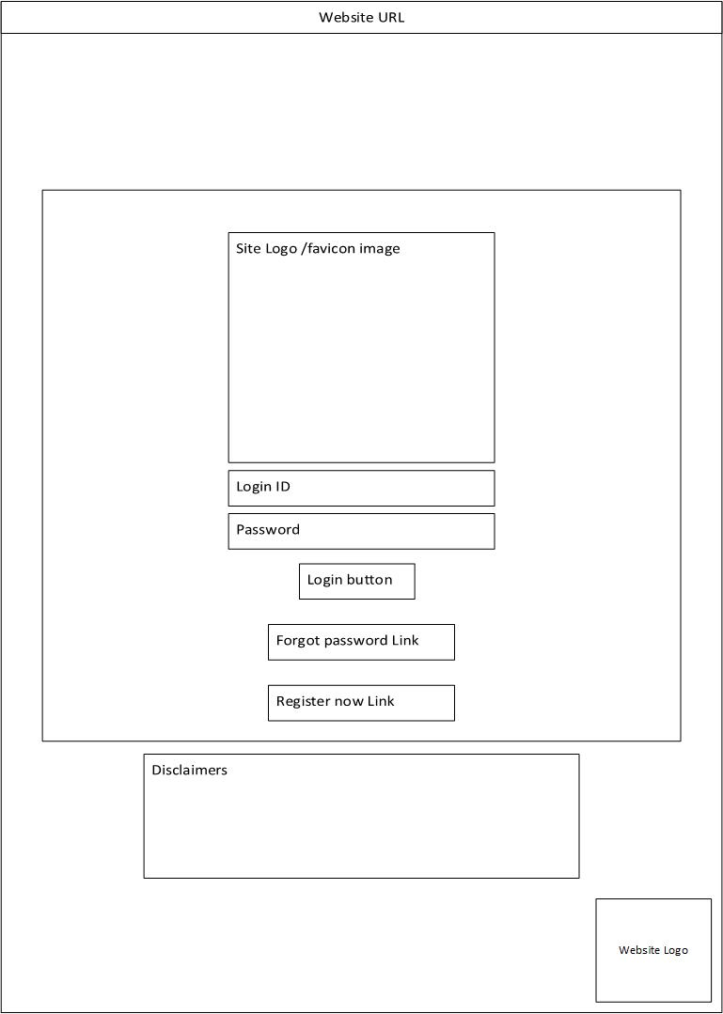USER LOG-IN (PRINT PAGE)

Figure 9 - The user log-in page can be accessed from the top right-hand corner.

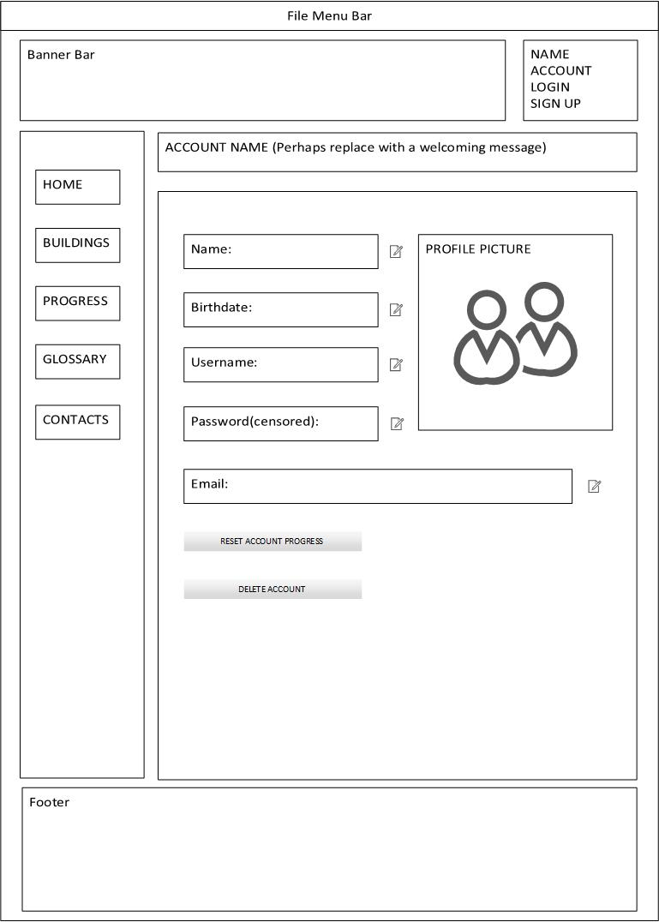**USER ADMINISTRATION**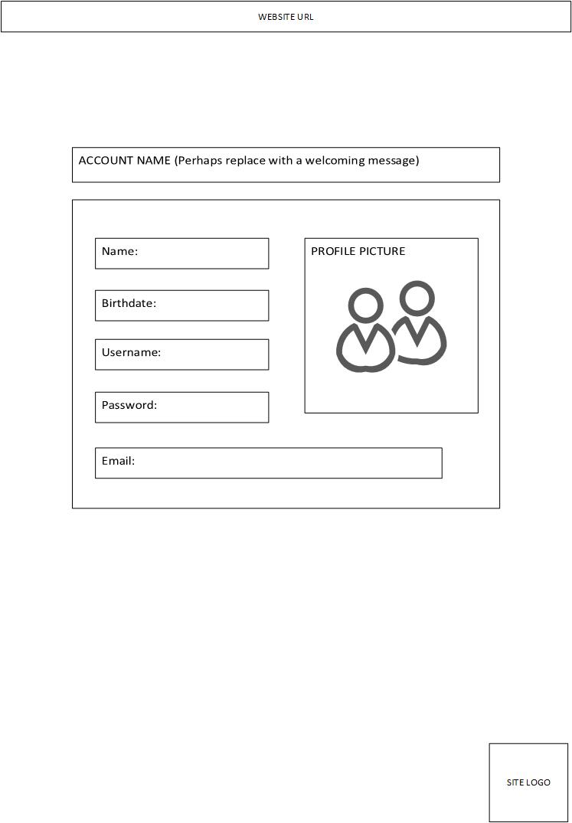USER ADMINISTRATION (PRINT PAGE)

Figure 10 - Users will be able to change their personal information on this page.

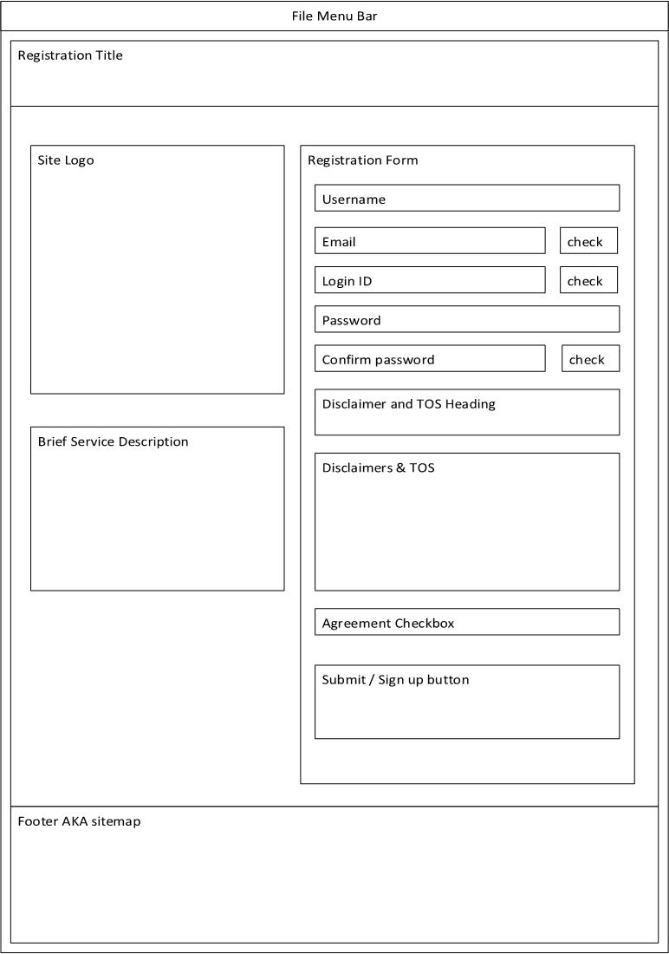**USER REGISTRATION**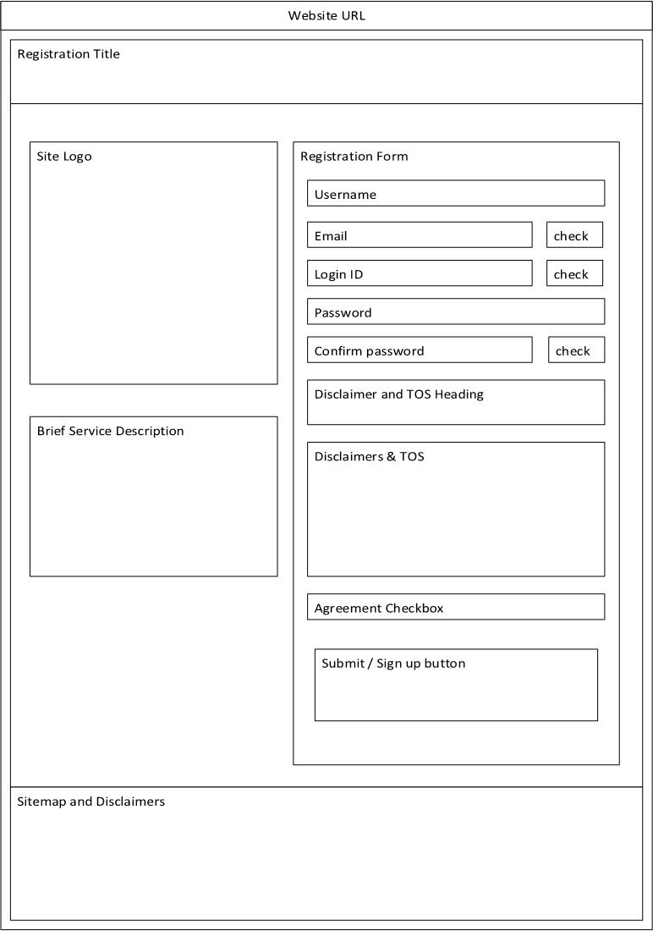USER REGISTRATION (PRINT PAGE)

Figure 11- User registration will be free-of-charge, and should ask for minimal information.

# APPENDIX 1: MILESTONE 1

## PROJECT SUMMARY

### **MISSION**

There are currently no readily accessible BCIT maps for new students; the Campus Tour given to students on the welcoming day does not fully cover the entire campus.

Every student coming into BCIT for the first time can agree that navigating the campus can be an arduous task. The campus tour provided by the student volunteers at our program orientation was somewhat underwhelming and hard to follow—the BCIT campus is simply too complicated to be able to learn in a single tour. While there are maps located throughout the campus—and even an interactive one in SW1 (as well as a map in the Safety Wise app)—they are either glitchy or non-portable.

Our mission is to create an interactive, portable, and intuitive map that can help visitors and new students alike to better navigate the hallways of BCIT, and make finding their destinations easier.

## 

### **GOAL/OBJECTIVE**

The purpose of the website is to:

1. Provide a clean and interactive map for new students and visitors so that they can better navigate the BCIT campus.
2. Motivate students and visitors to explore different areas of BCIT Burnaby campus

This site will make students actively search out relevant school property and to get them used to the campus as soon as possible, via a “quest” system. School sites that have already been visited will be highlighted on the website to reflect that effect.

### **COMPARASION WITH SIMILAR SITES**

Since our website works with “waypoints” and GPS locations to confirm if the user has reached a waypoint, it works similarly like the recent PokemonGO game’s Pokestops; where the user, when within range of a waypoint, can receive in-game items and perks. In constructing our website, we take our inspirations from the two examples below:

#### BCIT MAP

*Source:* <http://www.bcit.ca/map/>

The BCIT map website is very comprehensive and contains a lot of information and locations of where each building is situated. However, while the BCIT map is rather comprehensive, it can also be overwhelming and confusing to navigate—especially for a new student or visitor. Our website addresses this issue by removing most of the map and having our users slowly unlock each section by physically exploring the campus.

#### UBC MAP

*Source:* <http://www.maps.ubc.ca/PROD/index.php>

The UBC map website is less interactive compared to the BCIT map website due to the map being only a picture. However, this also provides the benefit of a faster loading time, as the website does not need to connect to Google Satellite. We plan to use pictures for our website maps as well to reduce loading time.

### **PROJECT SUMMARY**

The campus map website will provide an intuitive map to help students locate their buildings faster while giving quick notes on the general area. The site will have an image of the campus map with linked objects for each building. The site will also provide a GPS location service scan to show where the user is on the map. The website will function like an interactive quest game, where the user can unlock different sections of the map once he or she has physically visited the place. Below the map area will be a picture of what the particular building/place looks like followed by the description section and comments section where the user can input notes and comments. Figure 1 below is a rough draft of how the mobile website should look like.

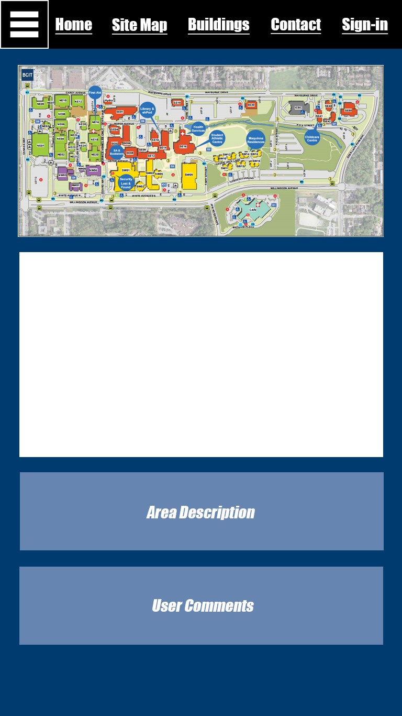

Figure 12: Initial Concept of the Website

### **MEASURING SUCCESS**

We plan to gauge the success of our website by the reviews and ratings from our users. We will have a review section on our webpage that allows the users to rate our website out of 5 and leave optional comments. This will also allow us to continue to improve our website based on user feedback. We may encourage users to rate and review by providing extra perks such as unlocking a map section.

## FUNCTIONAL REQUIREMENTS

### **THE LOG-IN FEATURE**

Those who want to interact and keep track of where they have been will be required to make a login username and password. This ensures that if a student wants to save their progress, they will be able to save that information to their User ID.

Those registered also have the option of leaving comments on places that they’ve been to. This allows the students to collaborate and help improve the map for future visitors and students.

### **USER AUTHENTICATION**

Once the user logs in, their name will be displayed on the top right corner of the webpage. Clicking on the name will display their user profile, which includes their login name, email, password (censored), and map unlock progress. There will be an edit button beside the password field if the user wishes to change the password.

## 

### **SERVER SIDE PROCESSING**

There will be a database on the server where the user’s login information is stored. The database will also store the user’s map “quest” progress.

## 

### **OTHER FEATURES**

### 

#### Feedback Box

There will be a comment section on each page where users can post suggestions.

#### List

We will have a page with a glossary of terms on the different names and jargons at BCIT. For example, the word “ehPod” would be a term listed under our glossary with the associated definition/explanation beside it.

#### Contact Us

There will be an option for users to contact us in the case of any problems, issues, or bugs. This will most likely be in form of a message box that the users can fill out and submit through the website.

## PROJECT EXECUTION PLAN

## 

### **SCHEDULE**

**Week 1**

Project proposal, rough layout of work plan, segment responsibilities

**Week 2**

Website scaffolding, plan on graphics - custom if need be

Back-end development talks

**Week 3**

Complete basic layout of the website and colors selection

Start work on establishing user database and logistics.

**Week 4 + Week 5 + Week 6**

Code. Development phase

**Week 7 + Week 8 + Week 9**

Start of week 7: Review current progress

Week 8 + 9: Damage control if need be, continue coding.

**Week 10**

Final testing and verifications

**Week 11 + Week 12 + Week 13**

Float time.

## 

### **PLAN**

In order to make this website a success, communication and cooperation between team members is crucial. Our plan is to start early and try to work in pairs as much as possible. Depending on the size of the task and the capability of the team members, resource/task delegation and pairings may change.

### **ROLES**

Each member in the group has an assigned role.

1. Simon Wu: Project Leader
2. Ian Lo: Head Coder
3. Jacky Li: Document Control
4. Akemi Haraguchi: Website Aesthetics Designer

### **DEADLINES**

Members will meet every Wednesday after-class. Members are expected to arrive on time and be prepared for the meeting. We will attempt to schedule items ahead of time with individual due dates to ensure the overall project milestones are delivered on time. Following the first milestone, a project Gantt chart will be constructed in-order to better delegate resources and tasks. The project schedule will be updated on a weekly basis to reflect actual progresses.

### **ADDENDUM**

Regarding the difficult of our project objectives and scope, we suggest the following plan:

1. The core requirements of the project will be addressed first:
   1. Basic website interface
   2. Navigation menu
   3. Requirements listed on the project document
2. The GPS tracking function will be allotted low priority and attempted only if time allows
   1. As a result, the user “quest progress” function will only be implemented when all other core functions are complete and running smoothly.